

VG Engine 101

Tutorial



16.10.2015

Contents

GameObjects 2

Components 2

Drawable component 2

Text Component 3

Animation Component 3

Physics Component 4

Your Own Components 5

Sound 7

Custom Shader 7

Input 8

Camera 8

Screen 9

Windows Version 9

# GameObjects

**Include**

#include “engine/game/gameObject.h”

**Creation**

*Example of creating a GameObject named “Foo”:*

GameObject *Foo = new GameObject(“Foo”); // Creating GameObject

Scene mScene = new Scene(); // Creating Scene (if not already created)

mScene->getObjectPool()->addGameObject(test); // Adding GameObject to the scene

See “Components” section on how to add components for your GameObject.

# Components

## Drawable component

**Include**

#include “engine/game/quadrangleComponent.h” // For drawable quadrangles

#include “engine/game/triangleComponent.h” // For drawable triangles

**Creation**

**With texture:**

// Creating quadrangleComponent with the texture “test.png”

QuadrangleComponent *quadre = Game::getInstance()->getFactory()->createRenderComponent<QuadrangleComponent>(“test.png”);

// Creating triangleComponent with the texture “test.png”

TriangleComponent *triangle = Game::getInstance()->getFactory()->createRenderComponent<TriangleComponent>(“test.png);

**Without texture: Coming Soon™**

**Remember!**

**If you create drawable component with texture it is loaded from Asset folder set in game project!**

## Text Component

**Include**

#include “engine/game/textComponent.h”

**Creation**

// Creating text component with font & size

TextComponent* Text = game->getFactory()->create(“arial.ttf”, 16u);

Text->setText(“test”); // Optional: Modify the text

Text->setColour(0, 0, 255); // Optional: Modify the color (numbers between 0 and 255)

MyTextObject->addComponent(Text); // Add textComponent to your GameObject

## Animation Component

**Include**

#include “engine/game/animationcomponent.h”

**Creation**

*Example of creating an animated GameObject named “animationObject”.*

// Create a new GameObject

GameObject *animationObject = new GameObject(“Animation”);

// Create QuadrangleComponent spritesheet for the animated GameObject

QuadrangleComponent *animationComponent = game->getFactory()->createRenderComponent<QuadrangleComponent>(“spritesheet.png”);

// Add the QuadrangleComponent to the GameObject

animationObject->addComponent(animationComponent);

// Add TransformComponent for the GameObject so it will be placed somewhere later

TransformComponent *animationTransform = new TransformComponent(Vector2<int>(int positionX, int positionY), Vector2<int>(int sizeX, int sizeY), float rotation);

// Add the transformComponent to your GameObject

animationObject->addComponent(animationTransform);

// Create and add the animationComponent for your GameObject so it will be animated

animationObject->addComponent(new AnimationComponent(float animationInterval, int rowCount, int columnCount, int total frameCount));

IMPORTANT!!

// Create and add AnimationSystem for animationComponents to work!

AnimationSystem *animationSystem = new AnimationSystem();

game->addComponentSystem(scene, animationSystem);

// Add the animated GameObject to the scene

scene->addGameObject(animationObject);

## Physics Component

**Include**

#include "engine/game/physicsSystem.h"

#include "engine/game/physicsPolygonComponent.h"

// Create transform component for physics component

TransformComponent *physicsTransform = new TransformComponent(Vector2<float>(80, 64), Vector2<float>(64, 64), 0.0f);

// Create QuadrangleComponent

QuadrangleComponent *physicsQuadrangle = new QuadrangleComponent("sample.png");

// Create new physics polygon component with dynamic body

PhysicsPolygonComponent *physicsComponent = new PhysicsPolygonComponent(physicsTransform, PhysicsComponent::DYNAMIC, PhysicsSystem::world, 64, 64);

**NOTE Last 2 parameters are optional, if you don’t pass them, physics objects collision will be the same size as its defined in the transform component (same size as texture)**

// Add physics component to physics gameobject physicsTestObject ->addComponent(physicsComponent);

// Add transform to physics gameobject physicsTestObject ->addComponent(physicsTransform);

// Add QuadrangleComponent to physics gameobject physicsTestObject-

>addComponent(physicsQuadrangle);

## Your Own Components

*Example of creating a component called “MyComponent”*

**MyComponent.h**

#include <engine/game/component.h> //Include the base header

class MyComponent :public vg::Component //Public to vg::Component

{

public:

 TestComponent();

~TestComponent();

};

*Example of creating a System called “MySystem”*

**MySystem.h**

#include “engine/game/system.h”

using namespace vg;

class MySystem : public System

{

ShipSystem();

~ShipSystem();

void update(

};

**MySystem.cpp**

#include “MySystem.h”

#include “engine/game/game.h”

using namespace vg;

MySystem::MySystem() :System()

{

// Add your own code here

}

void MySystem::update(std::vector<vg::gameObject*> *gameObjects, float deltaTime)

{

if ((*it)->getName() == “mygameobject”)

{

// Add your own logic here

}

}

**Usage**

*Example of calling your own component in main.cpp*

MyComponent *myComponent = new MyComponent();

object->addComponent(myComponent);

MySystem *system = new MySystem(); // Remember to include

# Sound

**Include**

#include “engine/sound/AudioManager.h”

**Creation**

vg::sound::Sound* testSound = new vg::sound::Sound(“shoot.mp3”); // Creating a new sound

**Usage**

Game::getInstance()->getAudioManager()->addSound(*testSound); // Playing the made sound object

# Custom Shader

**Creation**

Place the shader soure files to “ProjectFolder/assets/shaders”.

**Usage**

Game::getInstance()->getGraphics()->switchShader(“vertex.glsl”, “fragment.glsl”);

# Input

**Include**

#include “engine/input/keyboard.h” // For keyboard

#include “engine/input/mouse.h” // For mouse

#include “engine/input/sensor.h” // For android sensors

#include “engine/input/touch.h” // For android touch

**Usage**

input::Keyboard:: // For keyboard

input::Mouse:: // For mouse

input::Sensor:: // For android sensors

input::Touch:: // For android touch

**For example:**

input::Touch::getIsReleased() // Returns whether touch is being released from the screen

# Camera

**Include**

# Screen

**Include**

# Windows Version

**Usage**

Select Win32 as solution platform.

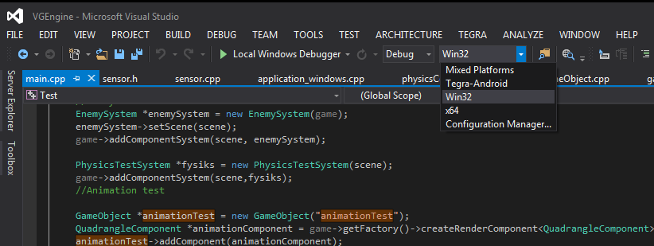

If Win32 doesn’t appear, do the following:

Build -> Configuration Manager

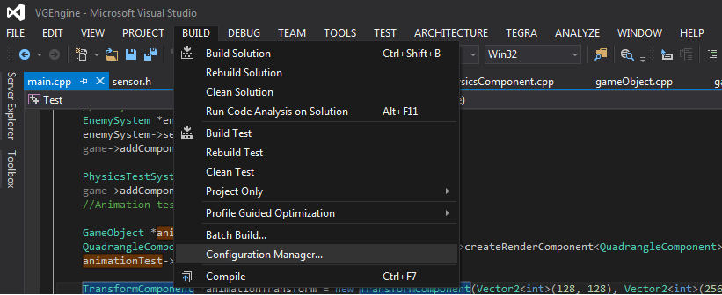

Active solution platform -> Choose “Win32” and then Press Close

